ASSIGNMENT NO.6: Data Manipulation and Table Management
Objective:
The objective of this practical is to help students understand how to manage table data in MySQL. Students will learn how to insert records using INSERT, update records using UPDATE, delete records using DELETE, and apply important constraints such as PRIMARY KEY, FOREIGN KEY, and NOT NULL.
Introduction to Data Manipulation and Table Management
Data manipulation means adding, changing, and deleting records from a database table. In MySQL, data manipulation is mainly performed using INSERT, UPDATE, and DELETE commands.
Table management means creating tables with proper structure and rules. These rules are called constraints. Constraints help maintain accuracy, uniqueness, and relationship between tables.
Common Data Manipulation Commands
Command | Purpose | Example Use
INSERT | Adds new records | Add new student details
UPDATE | Modifies existing records | Change student city or marks
DELETE | Removes records | Delete inactive student record

Common Constraints in MySQL
Constraint | Purpose | Example
PRIMARY KEY | Uniquely identifies each record | StudentID
FOREIGN KEY | Creates relationship between tables | CourseID in Student table
NOT NULL | Does not allow empty values | StudentName
Creating Database and Tables with Constraints
In this practical, we will create a database named CollegeDB. We will create two related tables: Course and Student.
The Course table stores course details. The Student table stores student details and connects each student with a course using CourseID.
Course Table Structure
Column Name | Data Type | Constraint | Description
CourseID | INT | PRIMARY KEY | Unique ID for each course
CourseName | VARCHAR(50) | NOT NULL | Name of the course
Fees | DECIMAL(10,2) | NOT NULL | Course fees
Student Table Structure
Column Name | Data Type | Constraint | Description
StudentID | INT | PRIMARY KEY | Unique ID for each student
StudentName | VARCHAR(50) | NOT NULL | Name of the student
Age | INT |  | Age of the student
City | VARCHAR(30) |  | City of the student
Column Name | Data Type | Constraint | Description
CourseID | INT | FOREIGN KEY | Refers to CourseID in Course table
MySQL Code
CREATE DATABASE CollegeDB;
USE CollegeDB;
CREATE TABLE Course (CourseID INT PRIMARY KEY, CourseName VARCHAR(50) NOT
NULL, Fees DECIMAL(10,2) NOT NULL );
CREATE TABLE Student (StudentID INT PRIMARY KEY, StudentName VARCHAR(50) NOT NULL, Age INT, City VARCHAR(30), CourseID INT, FOREIGN KEY (CourseID)
REFERENCES Course(CourseID) );

Explanation

| SQL Part | Purpose |

| `CREATE DATABASE CollegeDB;` | Creates a new database |
`USE CollegeDB;` | Selects the database |
| `PRIMARY KEY` | Ensures unique values in ID column |
| `NOT NULL` | Ensures value cannot be left blank |
| `FOREIGN KEY` | Connects Student table with Course table |
| `REFERENCES Course(CourseID)| Links Student.CourseID with Course.CourseID

3. Inserting Data using INSERT

The `INSERT` command is used to add new records into a table. Before inserting student rec ords, course records should be inserted first because the `Student` table depends on the `Cour se` table through a foreign key.

Insert Records into Course Table

INSERT INTO Course
(CourseID, CourseName, Fees)
VALUES
(101, 'BSc IT', 45000.00), (102, 'BCA', 40000.00),
(103, 'BSc CS', 42000.00),
(104, 'Data Science', 55000.00);
Insert Records into Student Table
INSERT INTO Student (StudentID, StudentName, Age, City, CourseID) VALUES
(1, 'Rahul Sharma', 20, 'Mumbai', 101), (2, 'Priya Patil', 19, 'Pune', 102), (3, 'Aman Verma', 21, 'Nashik', 103),
(4, 'Sneha Joshi', 20, 'Mumbai', 101), (5, 'Karan Mehta', 22, 'Thane',
102), (6, 'Neha Shah', 19, 'Pune', 104);

Course Table Output
CourseID | CourseName | Fees
101 | BSc IT | 45000.00
102 | BCA | 40000.00
103 | BSc CS | 42000.00
104 | Data Science | 55000.00

Student Table Output
StudentID | StudentName | Age | City | CourseID
1 | Rahul Sharma | 20 | Mumbai | 101
2 | Priya Patil | 19 | Pune | 102
3 | Aman Verma | 21 | Nashik | 103
4 | Sneha Joshi | 20 | Mumbai | 101
5 | Karan Mehta | 22 | Thane | 102
6 | Neha Shah | 19 | Pune | 104

Explanation
Point | Description
Course records inserted first | Because Student table uses CourseID as foreign key
Student records inserted later | Each student is assigned a valid CourseID
Invalid CourseID not allowed | MySQL will reject a Student record if CourseID does not exist in Course table

Updating Records using UPDATE
The UPDATE command is used to modify existing records in a table. It is commonly used when there is a change in student details, course fees, city, age, or any other stored value.
Syntax
UPDATE table_name SET column_name = new_value WHERE condition;
Example 1: Update Student City
UPDATE Student SET City = 'Mumbai' WHERE StudentID = 2;
Output After Update
StudentID | StudentName | Age | City | CourseID
2 | Priya Patil | 19 | Mumbai | 102
Example 2: Update Course Fees
UPDATE Course SET Fees = 47000.00 WHERE CourseID = 101;
Output After Update
CourseID | CourseName | Fees
101 | BSc IT | 47000.00
Important Note
Always use WHERE with UPDATE. If WHERE is not used, all records in the table may get updated.
Example of Wrong Query
UPDATE Student SET City = 'Mumbai';
Problem
Issue | Explanation
Missing WHERE clause | Updates city of all students
Data loss risk | Original city values may be overwritten
Poor practice | Should be avoided in practical work

5. Deleting Records using DELETE
The DELETE command is used to remove records from a table. It should be used carefully because deleted records may not be recovered unless backup is available.
Syntax
DELETE FROM table_name WHERE condition;
Example: Delete One Student Record
DELETE FROM Student WHERE StudentID = 6;
Output After Delete
StudentID | StudentName | Age | City | CourseID
1 | Rahul Sharma | 20 | Mumbai | 101
2 | Priya Patil | 19 | Mumbai | 102
3 | Aman Verma | 21 | Nashik | 103
4 | Sneha Joshi | 20 | Mumbai | 101
5 | Karan Mehta | 22 | Thane | 102
Important Note
Always use WHERE with DELETE. If WHERE is not used, all records will be deleted from the table.
Example of Wrong Query
DELETE FROM Student;
Problem
Issue | Explanation
Missing WHERE clause | Deletes all records from Student table
High risk | Complete table data will be removed
Should be avoided | Use condition carefully
6. Applying PRIMARY KEY, FOREIGN KEY, and NOT NULL Constraints
Constraints are rules applied to table columns. They help maintain valid, accurate, and reliable data.
Constraint Summary
Constraint | Purpose | Example
PRIMARY KEY | Uniquely identifies each row | StudentID
FOREIGN KEY | Connects one table to another table | CourseID
NOT NULL | Does not allow blank values | StudentName
Example 1: PRIMARY KEY Constraint
CREATE TABLE Department (DepartmentID INT PRIMARY KEY, DepartmentName VARCHAR(50) NOT NULL );
Explanation
Column | Constraint | Meaning
DepartmentID | PRIMARY KEY | Duplicate values not allowed
DepartmentName | NOT NULL | Department name cannot be empty
Example 2: FOREIGN KEY Constraint
CREATE TABLE Faculty (FacultyID INT PRIMARY KEY,FacultyName VARCHAR(50) NOT
NULL, DepartmentID INT,FOREIGN KEY (DepartmentID) REFERENCES
Department(DepartmentID) );
Explanation
Column | Constraint | Meaning
FacultyID | PRIMARY KEY | Unique faculty ID
FacultyName | NOT NULL | Faculty name is required
DepartmentID | FOREIGN KEY | Must match DepartmentID from Department table
Example 3: NOT NULL Constraint
CREATE TABLE AdminUser (UserID INT PRIMARY KEY,UserName VARCHAR(50) NOT NULL, Email VARCHAR(60) NOT NULL );
Explanation
Column | Constraint | Meaning
UserName | NOT NULL | Username must be entered
Email | NOT NULL | Email cannot be left blank
Final Summary Table
Concept | MySQL Command/Constraint | Purpose
Insert data | INSERT INTO | Adds new records
Update data | UPDATE | Modifies existing records
Delete data | DELETE | Removes records
Unique record | PRIMARY KEY | Prevents duplicate ID
Table relationship | FOREIGN KEY | Links two related tables
Required value | NOT NULL | Prevents empty values
Safe update/delete | WHERE | Applies change to selected records only

Questions:
Q1) Create a MySQL database named CollegeDB and create two tables: Course and Student.
Course Table
Column Name | Data Type | Constraint
CourseID | INT | PRIMARY KEY
CourseName | VARCHAR(50) | NOT NULL
Fees | DECIMAL(10,2) | NOT NULL
Student Table
Column Name | Data Type | Constraint
StudentID | INT | PRIMARY KEY
StudentName | VARCHAR(50) | NOT NULL
Age | INT
City | VARCHAR(30)
CourseID | INT | FOREIGN KEY

CREATE TABLE Course (
CourseID INT PRIMARY KEY,
CourseName VARCHAR (50) NOT NULL,
Fees DECIMAL (10, 2) NOT NULL
) ;

CREATE TABLE Student (
StudentID INT PRIMARY KEY,
StudentName VARCHAR (50) NOT NULL,
Age INT,
City VARCHAR (30), CourseID INT,
FOREIGN KEY (CourseID) REFERENCES Course (CourseID)
) ;
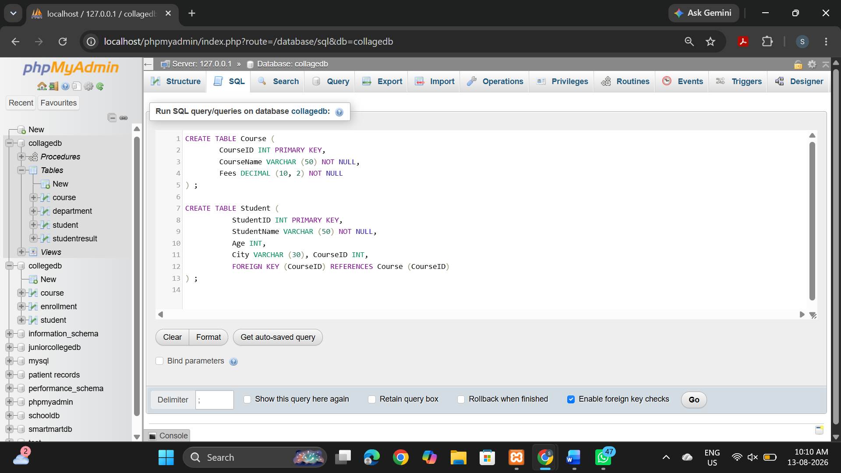
Q2) Insert at least 4 records into the Course table and 6 records into the Student table.
Make sure every student has a valid CourseID from the Course table.
Query
INSERT INTO Course (CourseID, CourseName, Fees)
VALUES
(101, 'BSC IT',45000.00)
(102,"BCA', 40000.00),
(103,'BSc CS', 42000.00),
(104, 'Data Science', 55000.00);

INSERT INTO Student
(StudentID, StudentName, Age, City, CourseID)
VALUES
(1,"Rahul Sharma', 20, ‘Mumbai', 101),
(2,'Priya Patil', 19, ’Pune', 102),
(3,'Aman Verma', 21, ‘Nashik', 103),
(4,'Sneha Joshi', 20, 'Mumbai', 101),
(5,'Karan Mehta', 22, "Thane',102),
(6, 'Neha Shah', 19, 'Pune', 104);

To verity:
SELECT * FROM Course;
SELECT * FROM Student;
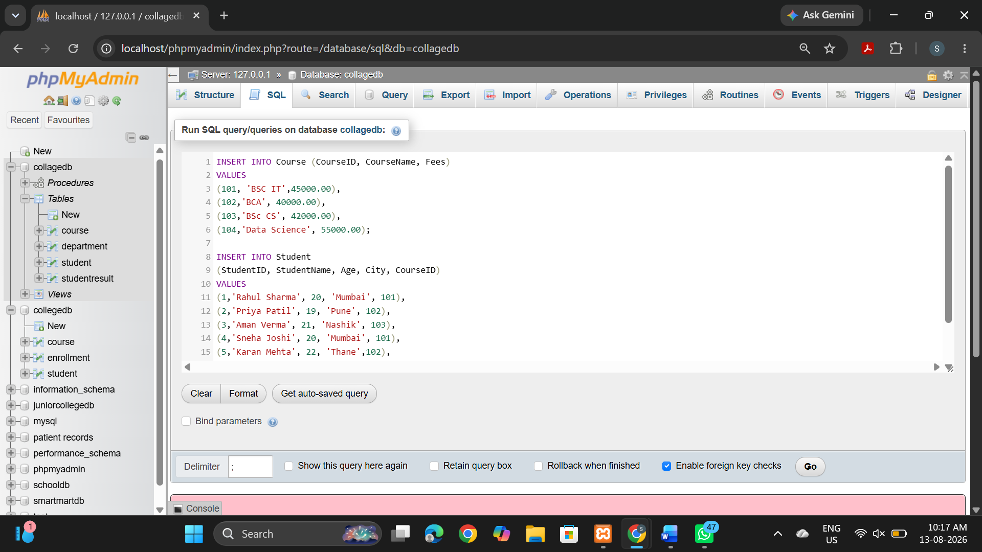
Q3) Write a MySQL query to insert one new student record into the Student table.
The record should include:
Field
StudentID
StudentName
Age
City
CourseID

INSERT INTO Student (StudentID, StudentName, Age, City, CourseID)
VALUES (7, 'Vikram Singh', 20, 'Delhi', 101);
VERIFY:
Select * from student
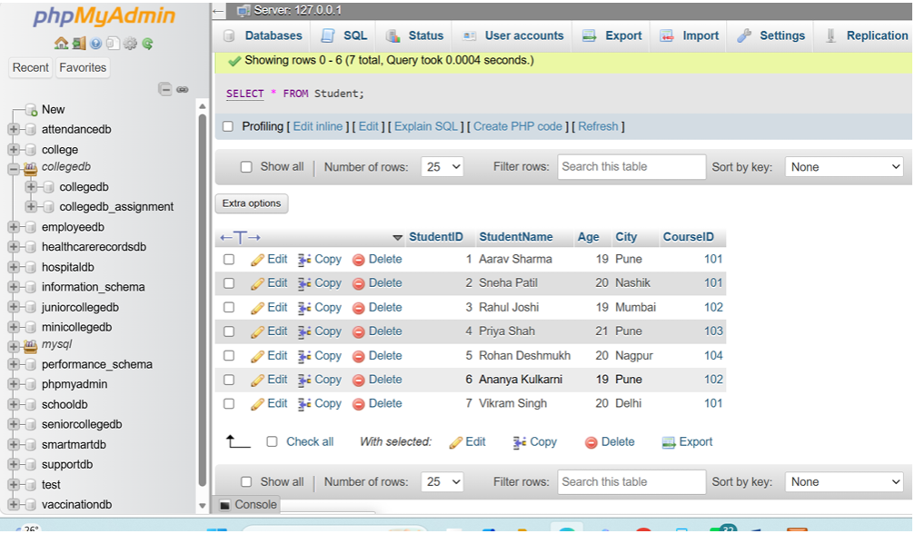

Q4) Write a MySQL query to update the city of a student using StudentID.
Example requirement:
Change Required
Update the city of StudentID 2 to Mumbai

UPDATE Student
SET City = 'Mumbai'
WHERE Student ID = 2;
Verify:
SELECT * FROM Student
WHERE StudentID = 2;
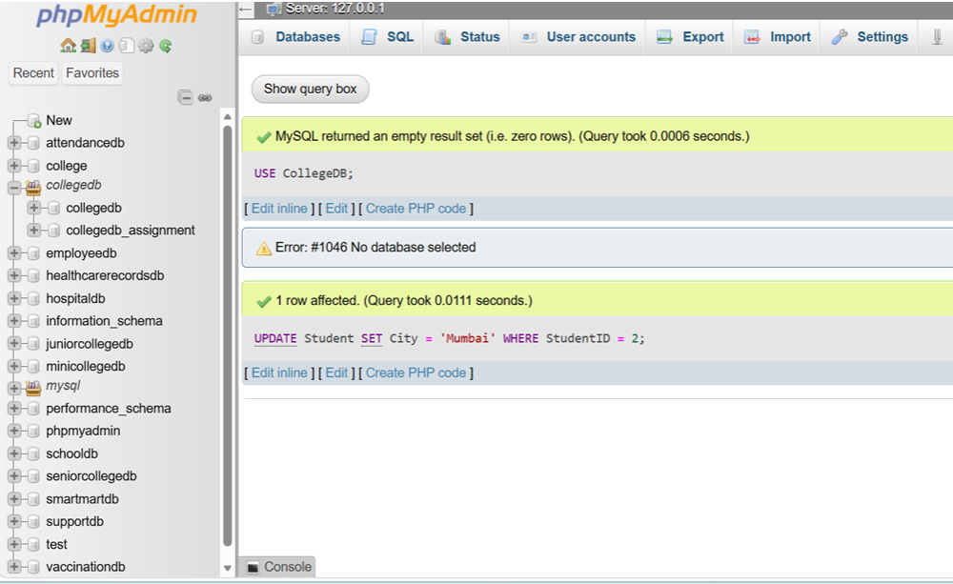
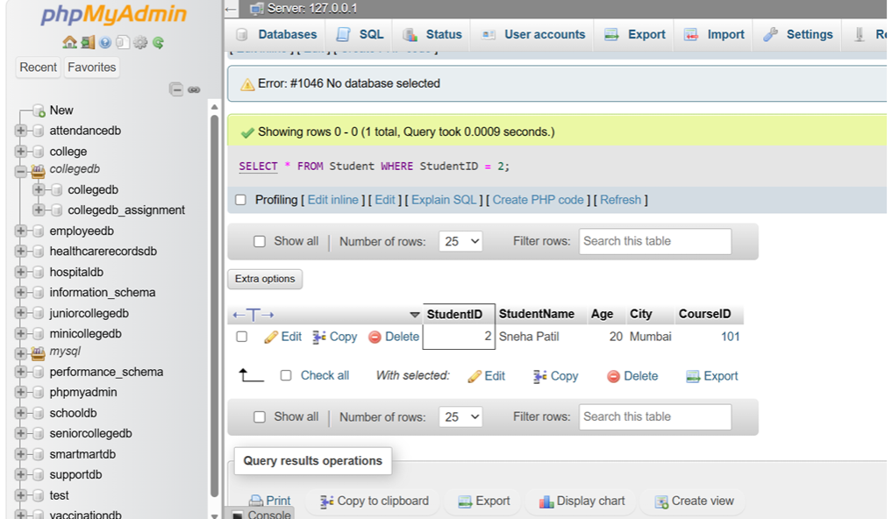Q5) Write a MySQL query to update the fees of a course using CourseID.
Example requirement:
Change Required
Update the fees of CourseID 101 to 47000
UPDATE Course
SET Fees = 47000.00
WHERE CourseID = 101;
Verify:
SELECT * FROM Course
WHERE CourseID = 101;
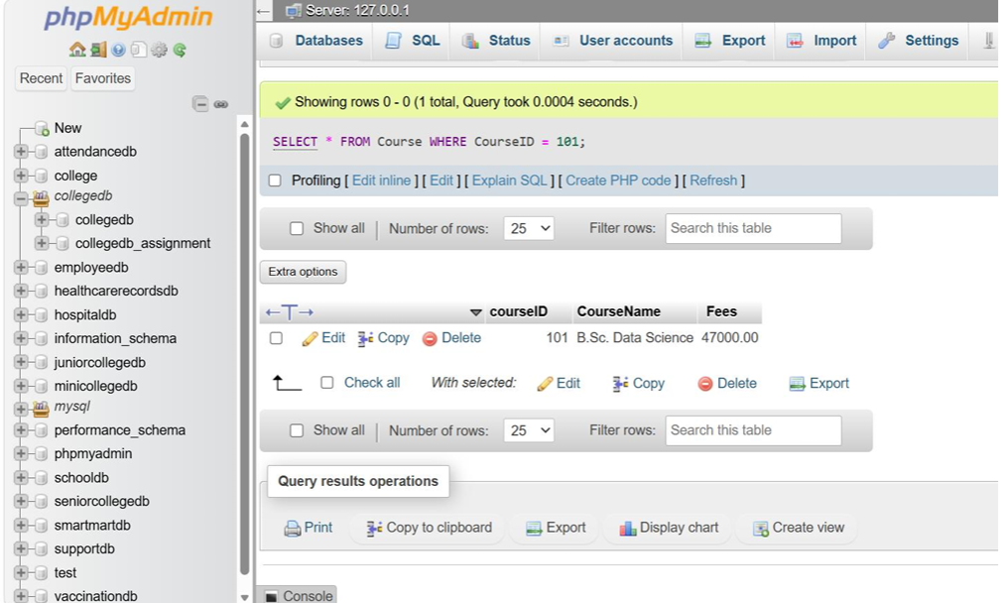

Q6) Write a MySQL query to delete one student record using StudentID.
Also write one line explaining why the WHERE clause is important while using DELETE.
DELETE FROM Student
WHERE StudentID = 6;
Verify:
SELECT * FROM Student;
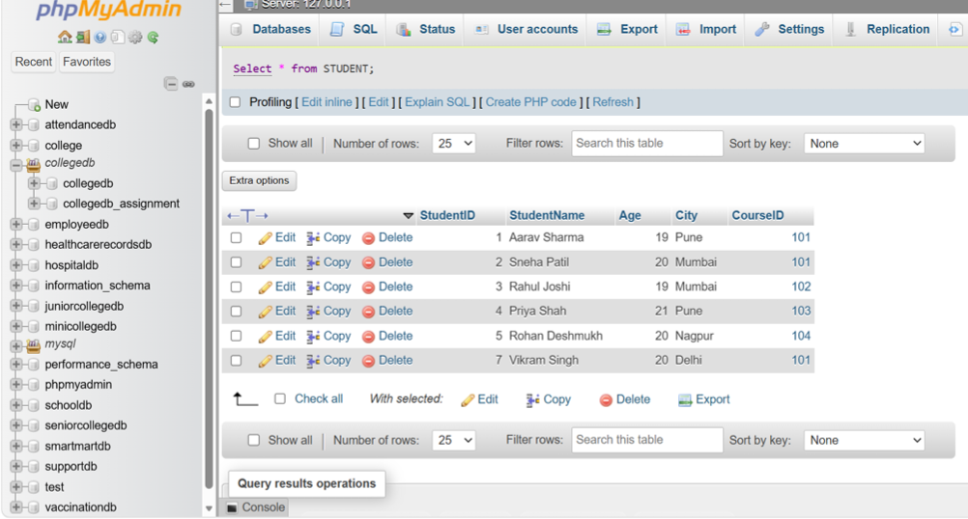

The WHERE clause ensures that only the specified student record is deleted.
Without WHERE, all records from the Student table would be deleted.

Assignment Evaluation
0: Not Done [ ]
1: Incomplete [ ]
2: Late Complete [ ]
3: Needs Improvement [ ]
4: Complete [ ]
5: Well Done [ ]
Signature of Instructor: _______________

